# Using third party COM components in Windows Azure application

## Include component in application

Steps:

1. Right click on folder to which the files should be added.
2. Select add🡪Existing Item🡪Point the dlls to be added.

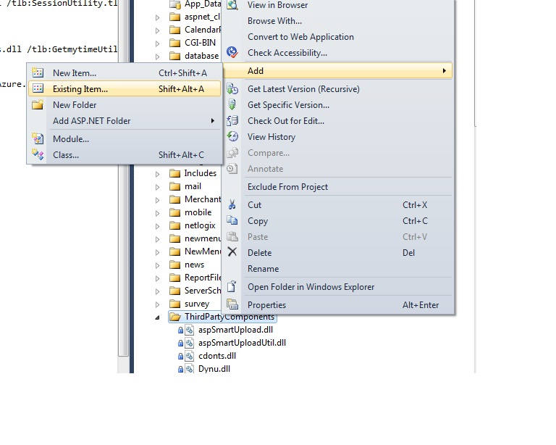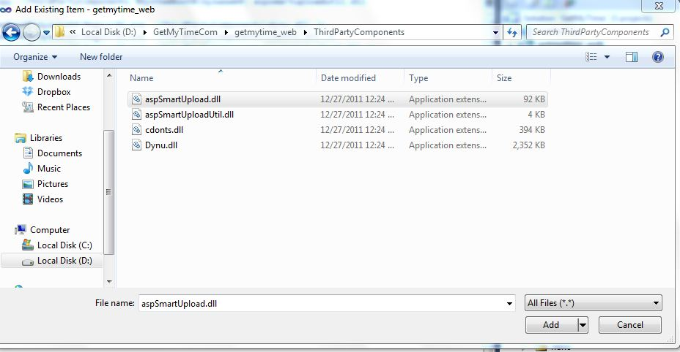

1. Click ADD.

The files you selected can be seen in the folder to which you added the dlls.

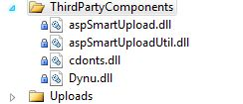

4. Right click on the com components and select properties.

5. Set property value for “Copy to output directory” to “Copy if newer” or “Copy Always”

## Create Command File

Steps:

1. Open new notepad

2. Save as “CommandFileName.cmd”

3. Include the following commands

* For register in gac utility

Eg: gacutil.exe /i SessionUtility.dll

* Expose the dllname.dll as a COM object using the regasm.exe

Eg: %SystemRoot%\microsoft.net\framework\v4.0.30319\regasm.exe

SessionUtility.dll /tlb:SessionUtility.tlb /s

* use regsvr32.exe to register it

Eg: %SystemRoot%\Syswow64\Regsvr32.exe SessionManager.dll /s

4. Include the command file in project.

5. Right click on the command file and select properties.

6. Set property value for “Copy to output directory” to “Copy if newer” or “Copy Always”

## Configuration for startup task

Include configuration for startup task in “Servicedefenition.csdef” file as shown below:

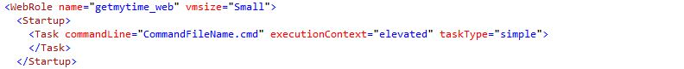

## Build and Deploy

Build and deploy the application and enjoy the power of COM components on Windows Azure environment as in any On-Premise server.